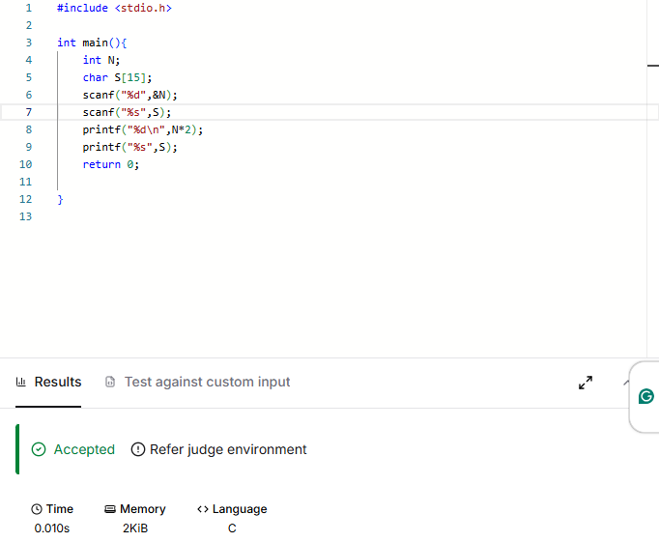

CODE-

#include <stdio.h>

int main(){
int N;
char S[15];
scanf("%d",&N);
scanf("%s",S);
printf("%d\n",N*2);
printf("%s",S);
return 0;

}

LINK-
https://www.hackerearth.com/practice/basic-programming/input-output/basics-of-input-output/practice-problems/algorithm/io-exercise/

